

***Electronic Thesis and Dissertation***

**A PROJECT REPORT ON**

**“Electronic Thesis and Dissertation”**

FOR

**GMIT**

SUBMITTED IN PARTIAL

FULFILLMENT OF INTERNSHIP PROJECT

UNDER THE GUIDEDANCE OF

Director

**Mr. Ravi Chhabra**

Supervisor

**Dr. Ei Ei Mon**

**SUBMITTED BY**

Ma Ei Po Po Aung

Ma Apirl Su

Ma Myo Myo

Ma Htet Htet Htun

Ma Su Sandi Myint Naing

Ma Shun Lae Nadi Moe

**University of Computer Studies (Mandalay)**

27.8.2018

**Group** **Members**

|  |  |  |  |
| --- | --- | --- | --- |
| **Roll No** | **Name** | **Signature** | **Date** |
| 5CS – 13 | Ma Ei Po Po Aung |  |  |
| 5CS – 14 | Ma Apirl Su |  |  |
| 5CS – 15 | Ma Myo Myo |  |  |
| 5CS – 16 | Ma Htet Htet Htun |  |  |
| 5CS – 17 | Ma Su Sandi Myint Naing |  |  |
| 5CS - 18 | Ma Shun Lae Nadi Moe |  |  |

Dr. Ei Ei Mon Signature/Date

**CONTENTS**

**Page Number**

**Abstract** i

**Acknowledgement** ii

**Declaration** iii

**List of figures** iv

**CHAPTER 1 INTRODUCTION 1**

1.1 Introduction 1

1.2 Background 2

1.2.1What is a firebase? 2

1.2.2 What is a firebase hosting? 2

1.2.3 What is a firebase database? 2

1.3 Objective of the project 3

1.4 Scope of Proposed System 3

**CHAPTER 2**  **METHDOLOGY 4**

2.1 Requirement Analysis 4

2.2 Software Selection 4

2.3 Project Plan 5

**CHAPTER 3 PROJECT DEVELOPMENT 6**

3.1 Design 6

3.1.1 Flow Chart Diagram 6

3.1.2 Use Case Diagram 8

3.1.3 Sequence Diagram 9

3.1.4 ETD Function 10

3.2 Implementation **20**

3.2.1 Database Implementation 20

3.3 Testing **22**

3.3.1 Integration Testing 22

**CHAPTER 4 EVALUATION AND CONCLUSION 25**

4.1 Conclusion 25

4.2 Advantages of the project 25

4.3 Disadvantages of the project 25

4.4 Further Extensions 26

**References 26**

**Abstract**

Electronic Thesis and Dissertation System is a work submitted in support of candidature for a doctorate or master’s degree. Electronic version of theses and dissertations are called ETDs. This system is kind of Education website. In our system , users can search theses and dissertations of CU (Mdy) by Year, and can see abstract of the thesis, author name, supervisor name and the major. Users can also search books and theses of Otago University and Global ETD for more references.

For admin Panel, admins can insert, data into database, delete and retrieve data for database. Users can use our system with both smart phones and computers. For Front End, the system was implemented using material design (HTML, CSS).For Back End, this system was implemented using javascript and jQuery. And we also used Firebase Hosting and Database.

i

**ACKNOWLEDGEMENT**

First of all, we would like to express our very great appreciation to **U Kyaw Zwa Soe**, Rector of Computer University (Mandalay).

We also greatly thank to **Dr. San San Tin**, Pro-Rector of Computer University (Mandalay).

And sincerely thank to our teachers **Dr. Myat Thida Kyaw**, Head of faculty of Computer Science and **Dr. Aye Aye Chaw**, Head of faculty of Information Science Department.

We also deeply thank to our director **U Ravi Chhabra**, CEO of GMIT, for his patient training to gain experience in modern software development and trust to give us.

And then greatly thank to our supervisor **Dr. Ei Ei Mon**, Associate Professor of Computer University (Mandalay), for her valuable guidance and patient supervisor, presentation and correctness of the project.

We especially thanks to our parents and all our friends for providing encouragement and giving us a great support during internship program.

ii

**DECLARATION**

We declare that this project report or part of was not a copy of a document done by any organization, university any other institute or a previous student project group at Computer University (Mandalay) and was not copied from the Internet or other sources.

Project Details

|  |  |
| --- | --- |
| Project Title | Electronic Thesis and Dissertation System |
| Project ID | GMIT Company Internship |

iii

**List of Figures**

**Figure Page**

Figure (2.1) Project Plan 5

Figure (3.1) Flowchart Diagram For Admin 6

Figure (3.2) Flowchart Diagram For User 7

Figure (3.3) UseCase Diagram For ETD 8

Figure (3.4) Sequence Diagram For ETD 9

Figure (3.5) Navigation Bar Form 10

Figure (3.6) Home Page Form 11

Figure (3.7) Thesis Resource Form 12

Figure (3.8) Thesis Resource Form By Year And Title 13

Figure (3.9) Thesis Resource With Details 14

Figure (3.10) Publisher Form 15

Figure (3.11) Information Of The Title That User Click 16

Figure (3.12) Admin Form 17

Figure (3.13) Admin login Form With Email 17

Figure (3.14) Detail Information By Year For Admin 18

Figure (3.15) Learn More Form 18

Figure (3.16) Global ETD Form 19

Figure (3.17) Data Of Project 20

Figure (3.18) Data Of Each Year Under Project 21

Figure (3.19) Data Of Id Under Project 21

Figure (3.20) Testing 22

Figure (3.21) Allow Login And Check Permission22

Figure (3.22) Permit Authorization Person 23

Figure (3.23) Allow Login And Check Permission 24

Figure (3.24) Permission Deny When Not Given Authorization 24

**Chapter 1**

**Introduction**

* 1. **Introduction**

Nowadays, modern technologies are sharply developed. And most of the people widely use internet with mobile phones and computers for various purposes. Most of the universities around the world use online libraries. In that libraries, students can search books at every time and everywhere. It can save time and energy.

Our project ETD (Electronic thesis and dissertation), it mainly focuses to search easily theses and dissertations of Computer University (Mandalay) at one place. In our project, students can search theses with their abstracts from 2008 to 2016.

In our ETD project, students can also search theses reference books and global theses and dissertations from other universities around the world for various fields and major.

The aims of our ETD project is to save time and energy, to reduce paper works and familiar with electronic library.

* 1. **Background of the System**

**1.2.1What is firebase?**

* Firebase is a platform that makes developing android apps or web app easier.
* It is owned by Google and is easy to Integrate to projects
* It combines Database, Authentication, Storage, Hosting, Functions.
* **Database** – store data as a tree
* **Authentication** - Use firebase as a database to manage users
* **Hosting** – Offer lightweight configuration options for building web apps. We can easily rewrite URLs for client-side routing or set up custom headers.
* **Storage** - Store data by using firebase as backend such as images
* **Functions**- Automatically run backend code in response to events triggered by Firebase features and HTTPS requests.

**Among them ,We use firebase hosting and firebase database in our project.**

**1.2.2 What is a firebase hosting?**

The production-grade web content hosted for developers is called as firebase hosting. With the help of hosting, user can quickly and easily deploy web apps or content to the CDN (Global content delivery network) using a single command. Firebase hosting gives user a fast, secure, and reliable way to host the app’s static assets such as HTML, CSS, Javascript, and media files. It is very easy process in Firebase because it contains Custom domain support, and Global CDN. Whether users are sending a simple application landing page or a complex Progress Web App. Hosting gives user the infrastructure, features, and manage static website.

**1.2.3 What is a firebase database?**

A database is a collection of information that is organized so that it can be easily accessed, managed and updated. Data gets updated, expanded and deleted as new information is added.

The Firebase Realtime Database is a cloud-hosted database. Data is syned across all clients in realtime, and remains available when the app goes offline. Data is stored as JSON and synchronized in realtime to every connected client. When user build cross-platform apps with our iOS, Android, and JavaScript SDKs, all of the clients share one Realtime Database instance and automatically receive updates with the newest data. By utilizing this feature of Firebase, there is no necessity to make the own database. Firebase handles all the components that usually come along with creating a backend for applications. It gives an adaptable, expression-based rules language to define how the data should be organized and when information can be perusd from or composed to. When user point the app to the proper data source in Firebase, it will retrieve the data in real-time.

**1.3 Objectives of the project**

* To save time for taking thesis guideline and thesis information
* To help students be better prepared as knowledge workers
* To develop university digital library services and infrastructure
* To increase sharing and collaboration among university and students
* To enhance access to university research

**1.4 Scope of Proposed System**

The proposed project of Electronic Thesis and Dissertation is prescribed as follow;

* Manage Home, ThesisResource, Publisher, Admin, Search, Learn More
* View Home
* View ThesisResource
* View Publisher
* View Admin
* View Learn More

**CHAPTER 2**

**METHDOLOGY**

**2.1 Software Selection**

**Choose Programming Language**

We would like to use HTML, CSS, Javascript, jQuery, material design lite in our project because there are a lot of benefits to pick up languages in our windows form application.

* HTML describes the structure of Web pages using markup.
* CSS can control the layout of multiple web pages all at once. It describes how HTML elements are to be displayed on screen, paper, or in other media.
* Javascript is a high-level and interpreted programming language.
* JQuery is a fast, small, and feature-rich JavaScript library.
* Material Design Lite makes more liberal use of grid-based layouts, responsive animations and transitions, padding, and depth effects such as lighting and shadows.
* They are readily available and easy to access.

**Software Requirements**

* Firebase (Database and Hosting)
* Submit Text 3
* Git bash
* Git hub

**Hardware Requirements**

* Internet Access
* PC with Windows OS
* Mobile Phone

**2.2 Project Plan**

In understanding the system requirements and testing some features, we work together. UI/UX, Developer and testing and documentation, we work together. User Access Level/Access to pages, Project Manager and System analysis are discussed about the system to understand the user.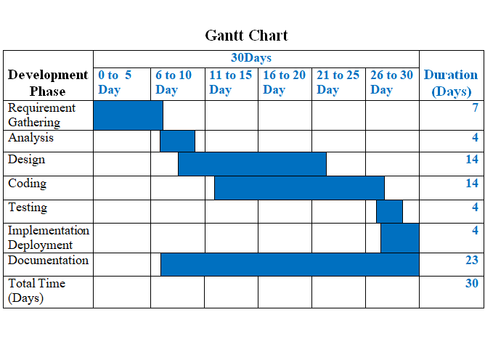

Figure (2.1) Project Plan

**CHAPTER 3**

**PROJECT DEVELOPMENT**

**3.1 Design**

**3.1.1 Flow Chart Diagram**

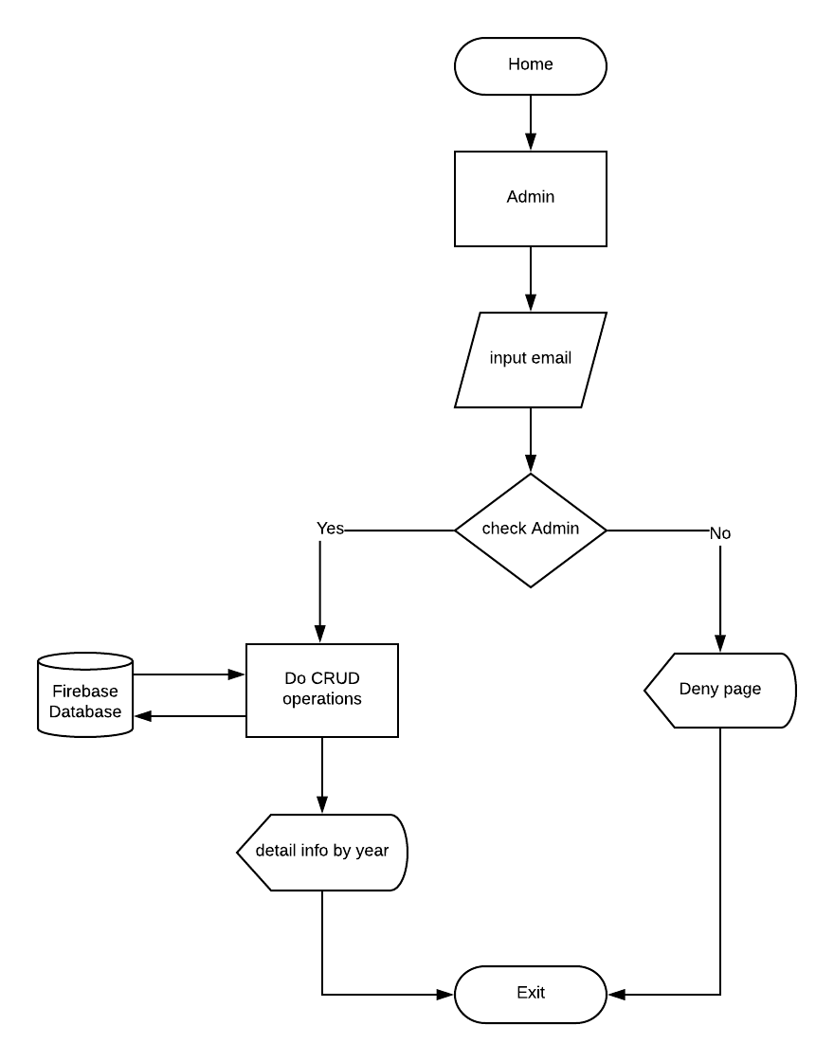

Figure (3.1) Flowchart Diagram For Admin

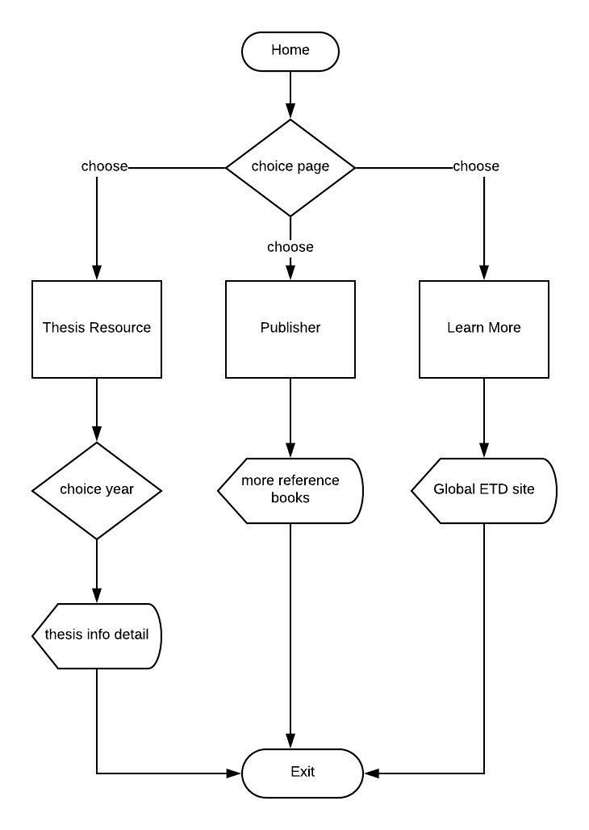

Figure (3.2) Flowchart Diagram For User

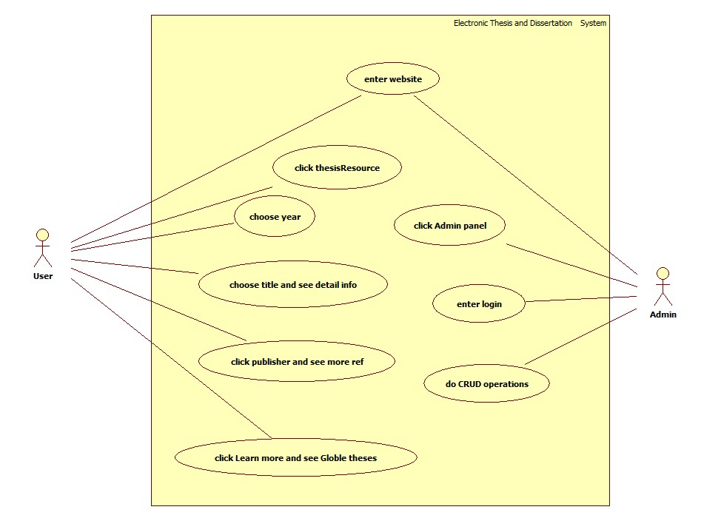

Figure (3.3) UseCase Diagram For ETD

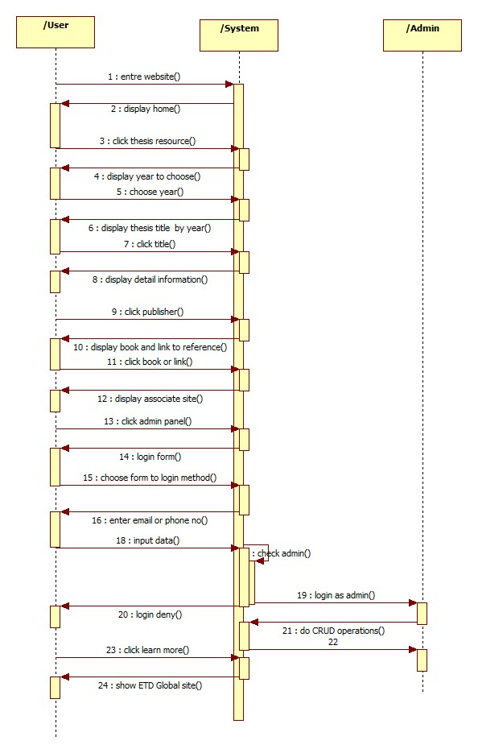

Figure (3.4) Sequence Diagram For ETD

**3.1.4 ETD Function**

In this system, we use navigation bar. When users click navigation bar, users can see Home, ThesisResource , Publisher, Admin and Learn More.

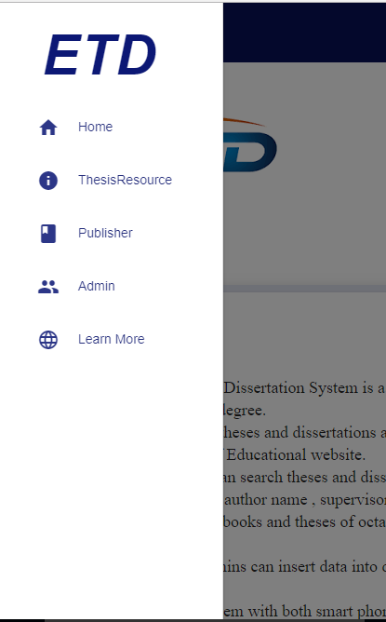

Figure (3.5) Navigation Bar Form

In Home Page form, we show Introduction, Type of Thesis, abstract, and objective.

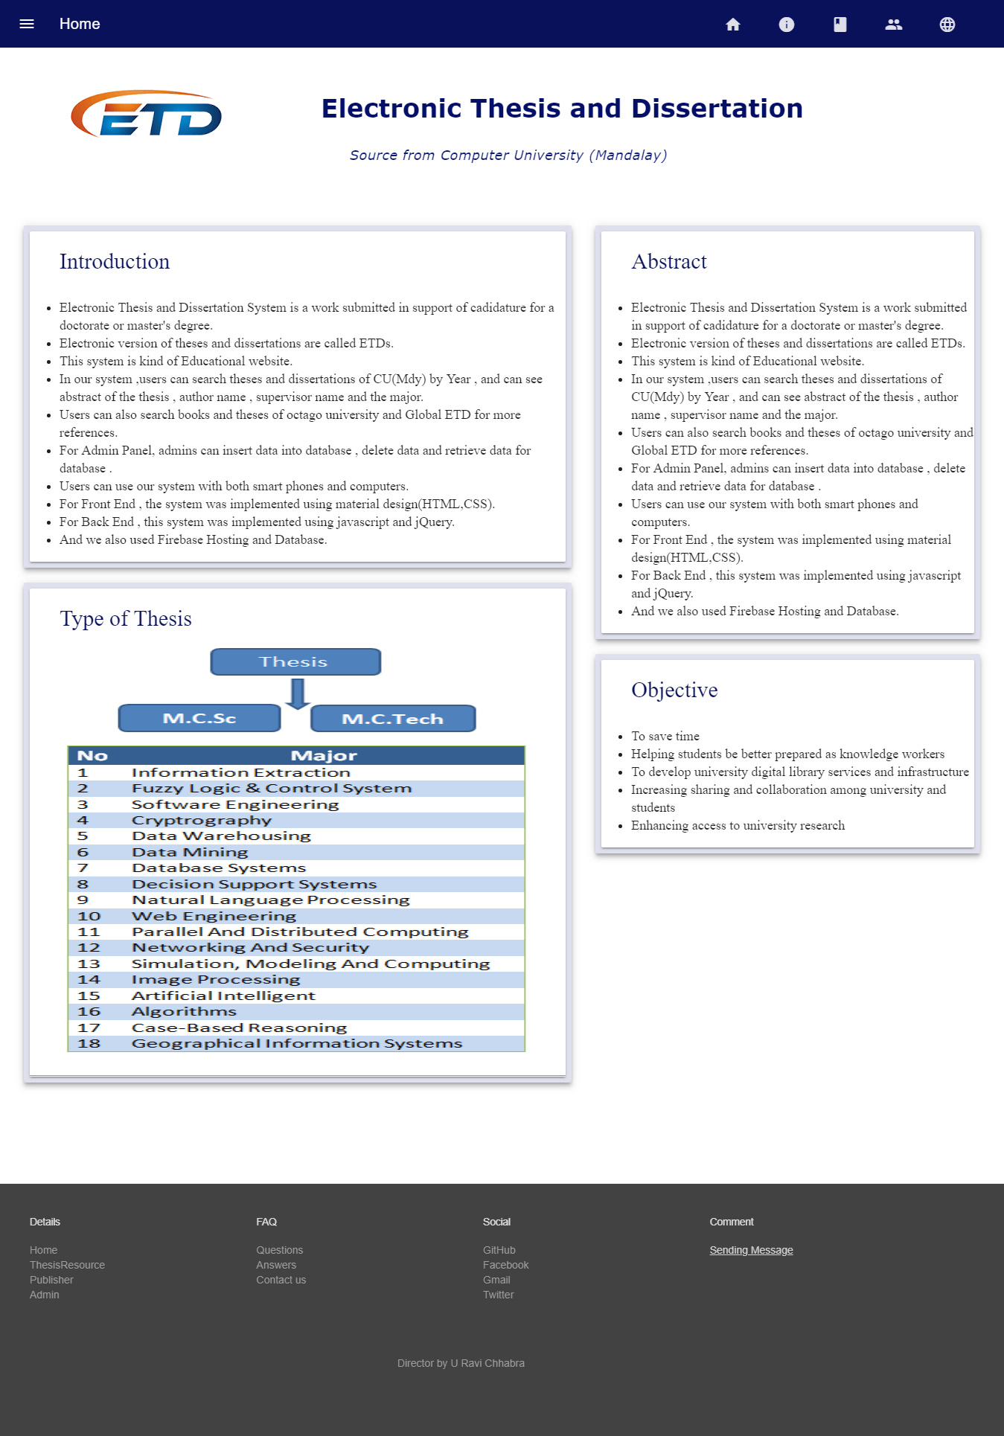

Figure (3.6) Home Page Form

In the following form,users can see thesis resource by year from 2008 to 2016.

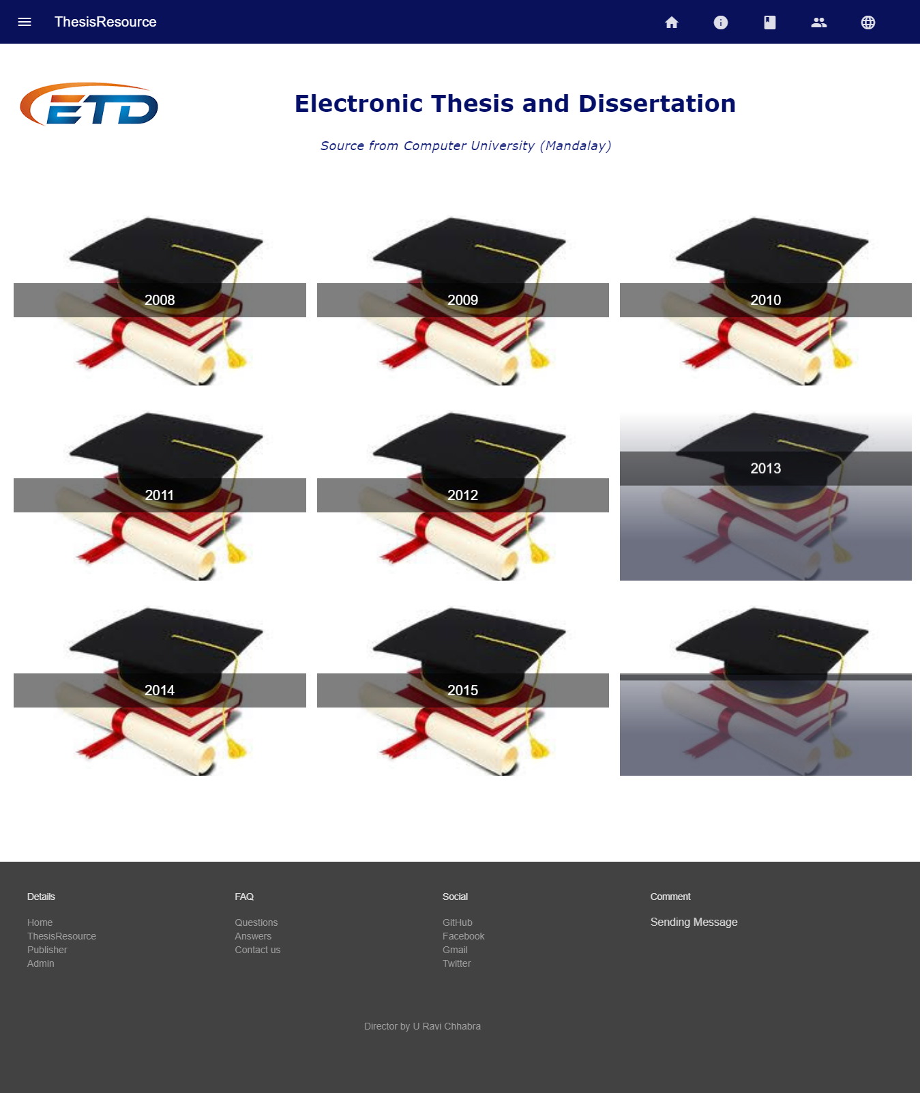

Figure (3.7) Thesis Resource Form

If user clicks 2008, user can see thesis titles in 2008.

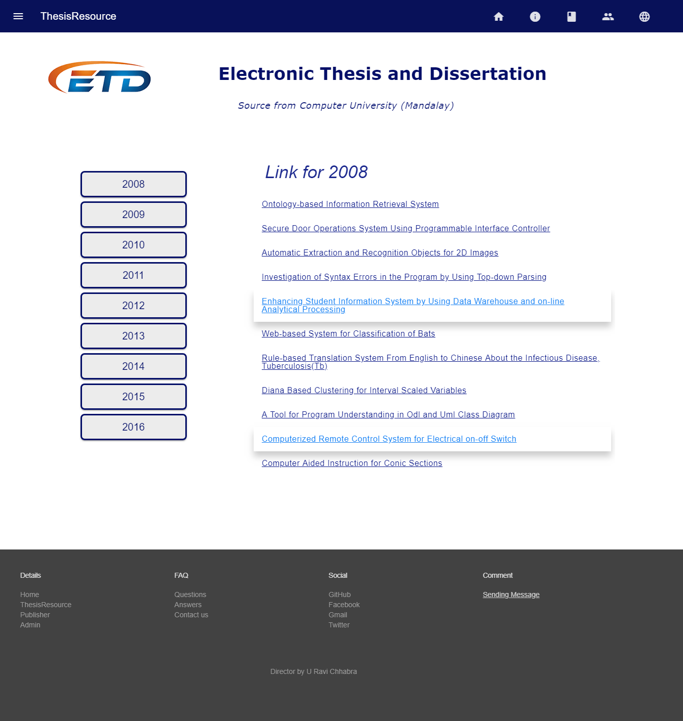

Figure (3.8) Thesis Resource Form By Year And Title

When user clicks thesis title, user can see the following form. There are Abstract of thesis, Author’s Name, Degree, Supervisor, Thesis Title, Major and Year.

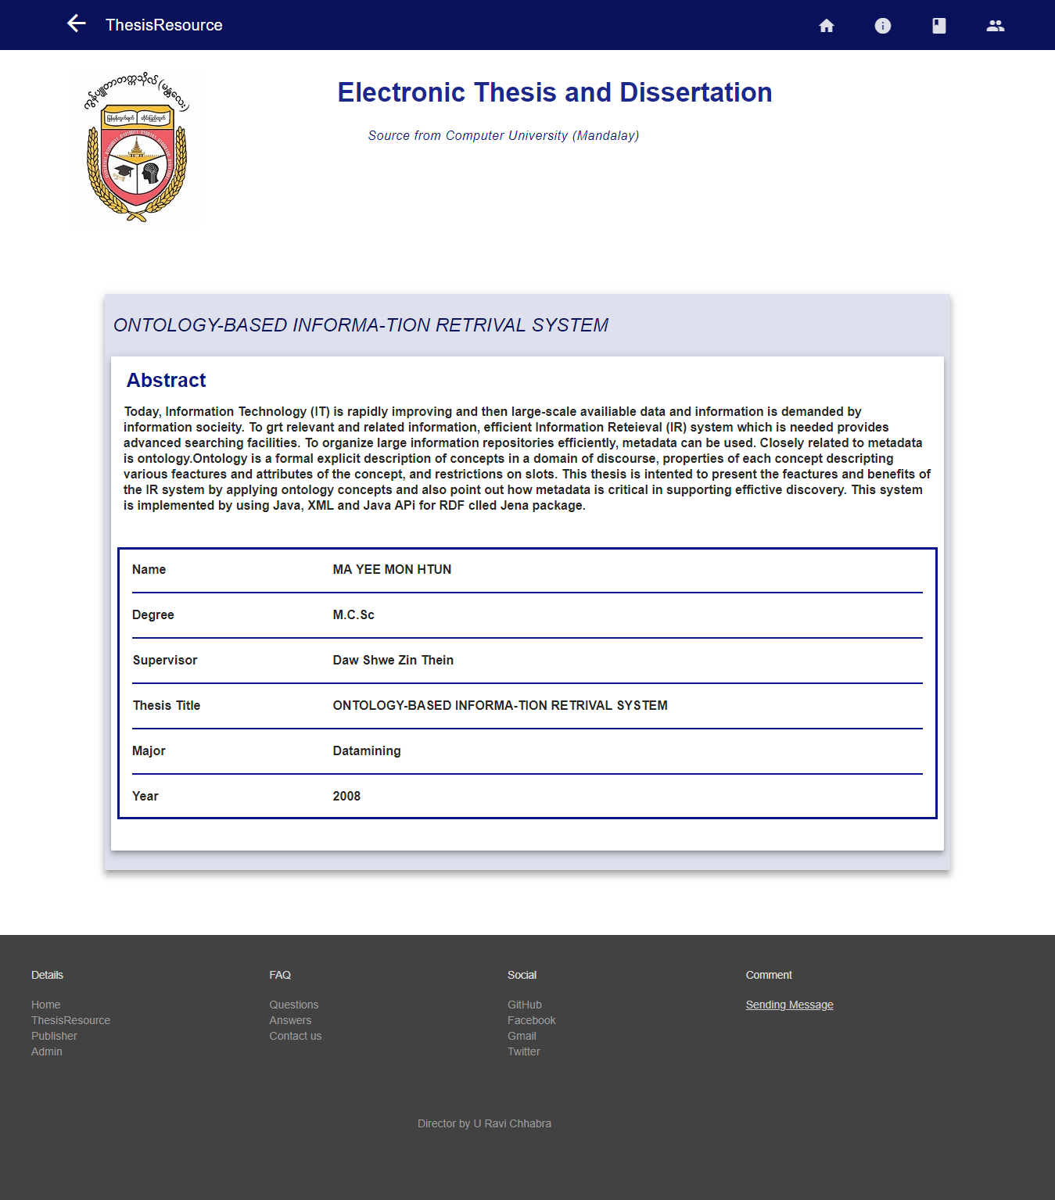

Figure (3.9) Thesis Resource With Details

User can see Books on doing research in Publisher.

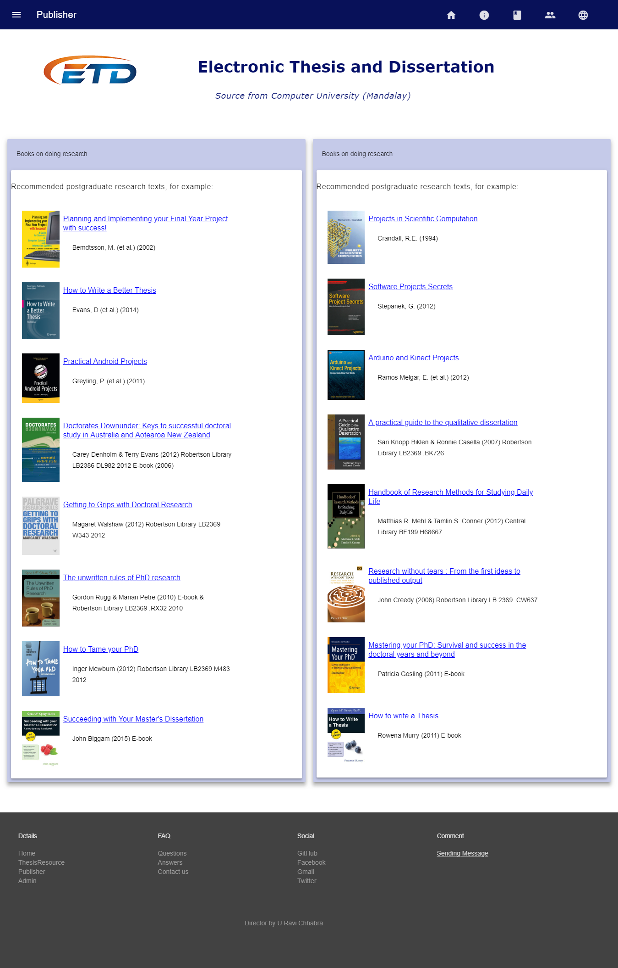

Figure (3.10) Publisher Form

When user clicks any title, user can see the information of the title that user click.

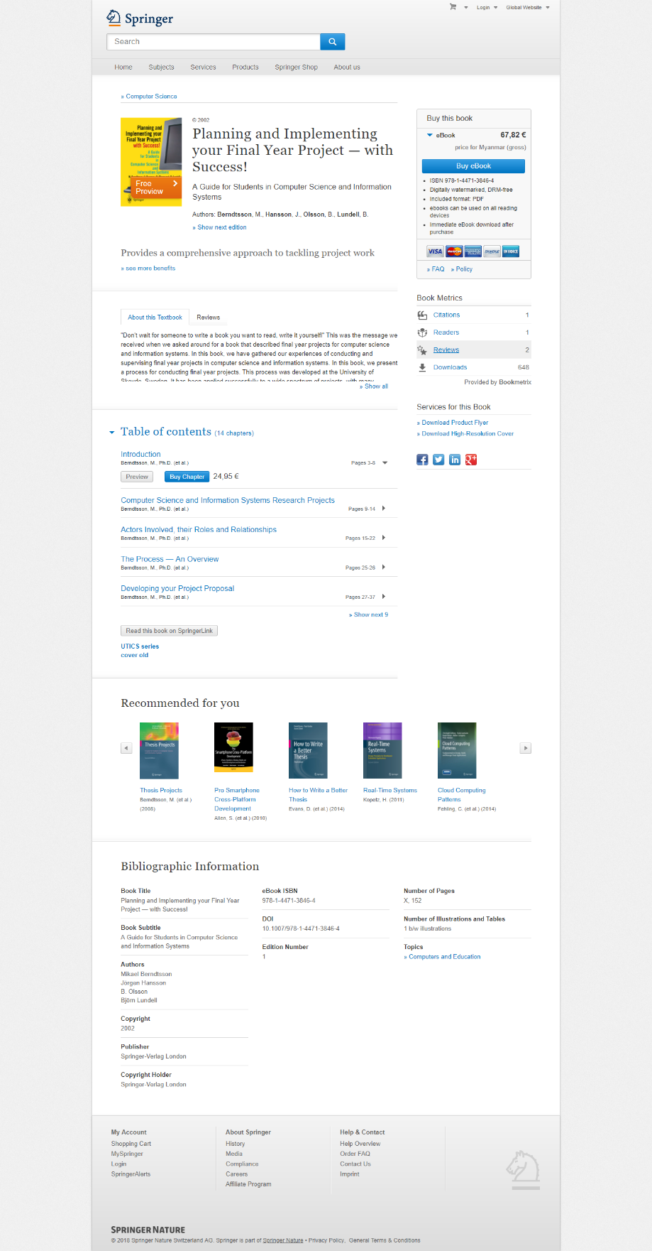

Figure (3.11) Information Of The Title That User Click

In the following form, admins can only login to create, delete, update and add data.

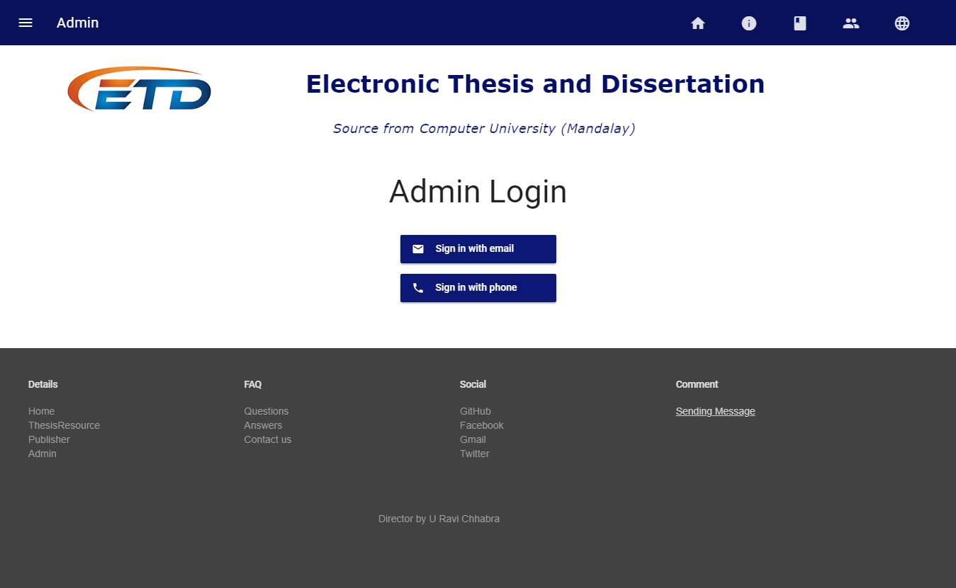

Figure (3.12) Admin Form

We design Admin login form to login not only email but also phone number. Admin need to create an account to login.

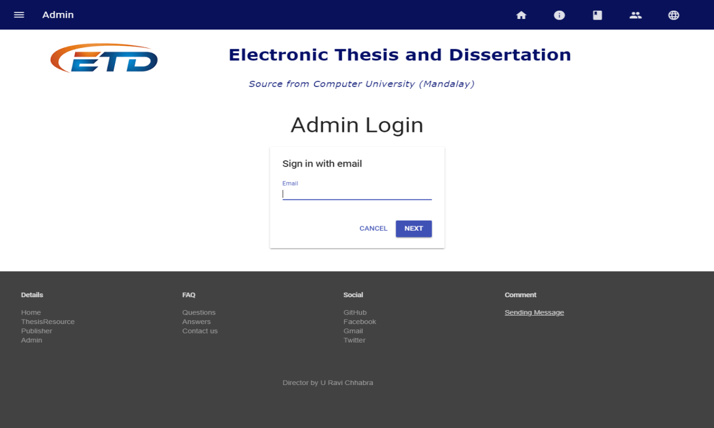

Figure (3.13) Admin Login Form With Email

After login, admins can create, update and delete data.

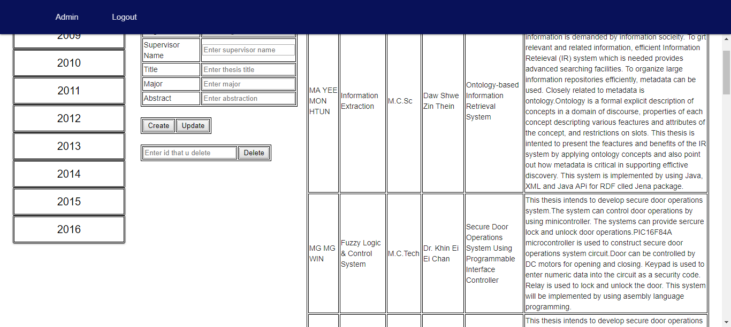

Figure (3.14) Detail Information By Year For Admin

In the below form, user can search Theses in global and it combines with 5,111,718 electronic theses and dissertations where can find any fields that you want .

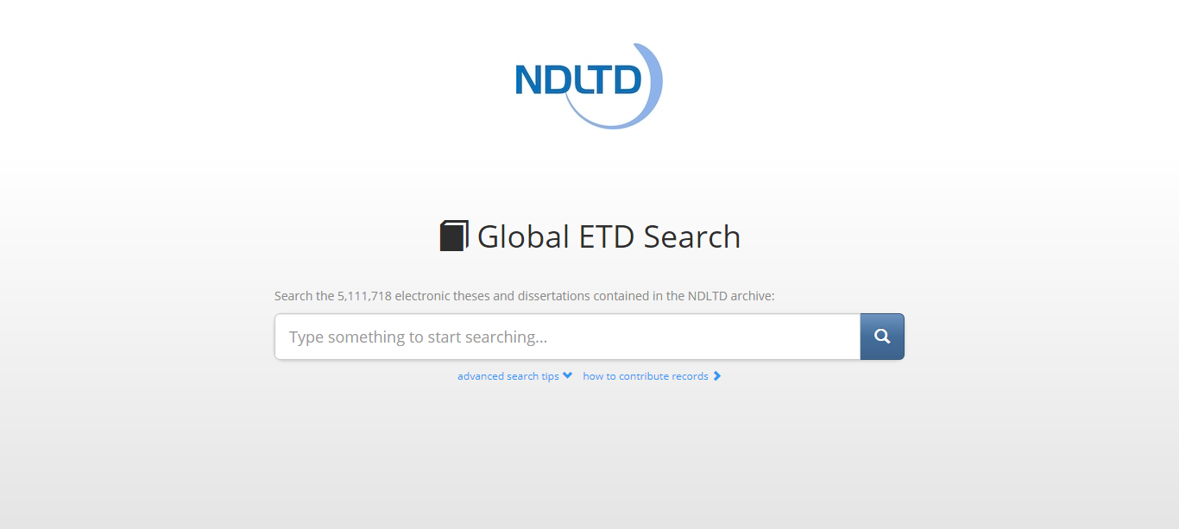

Figure (3.15) Learn More Form

In Global ETD Search, user can see like this.

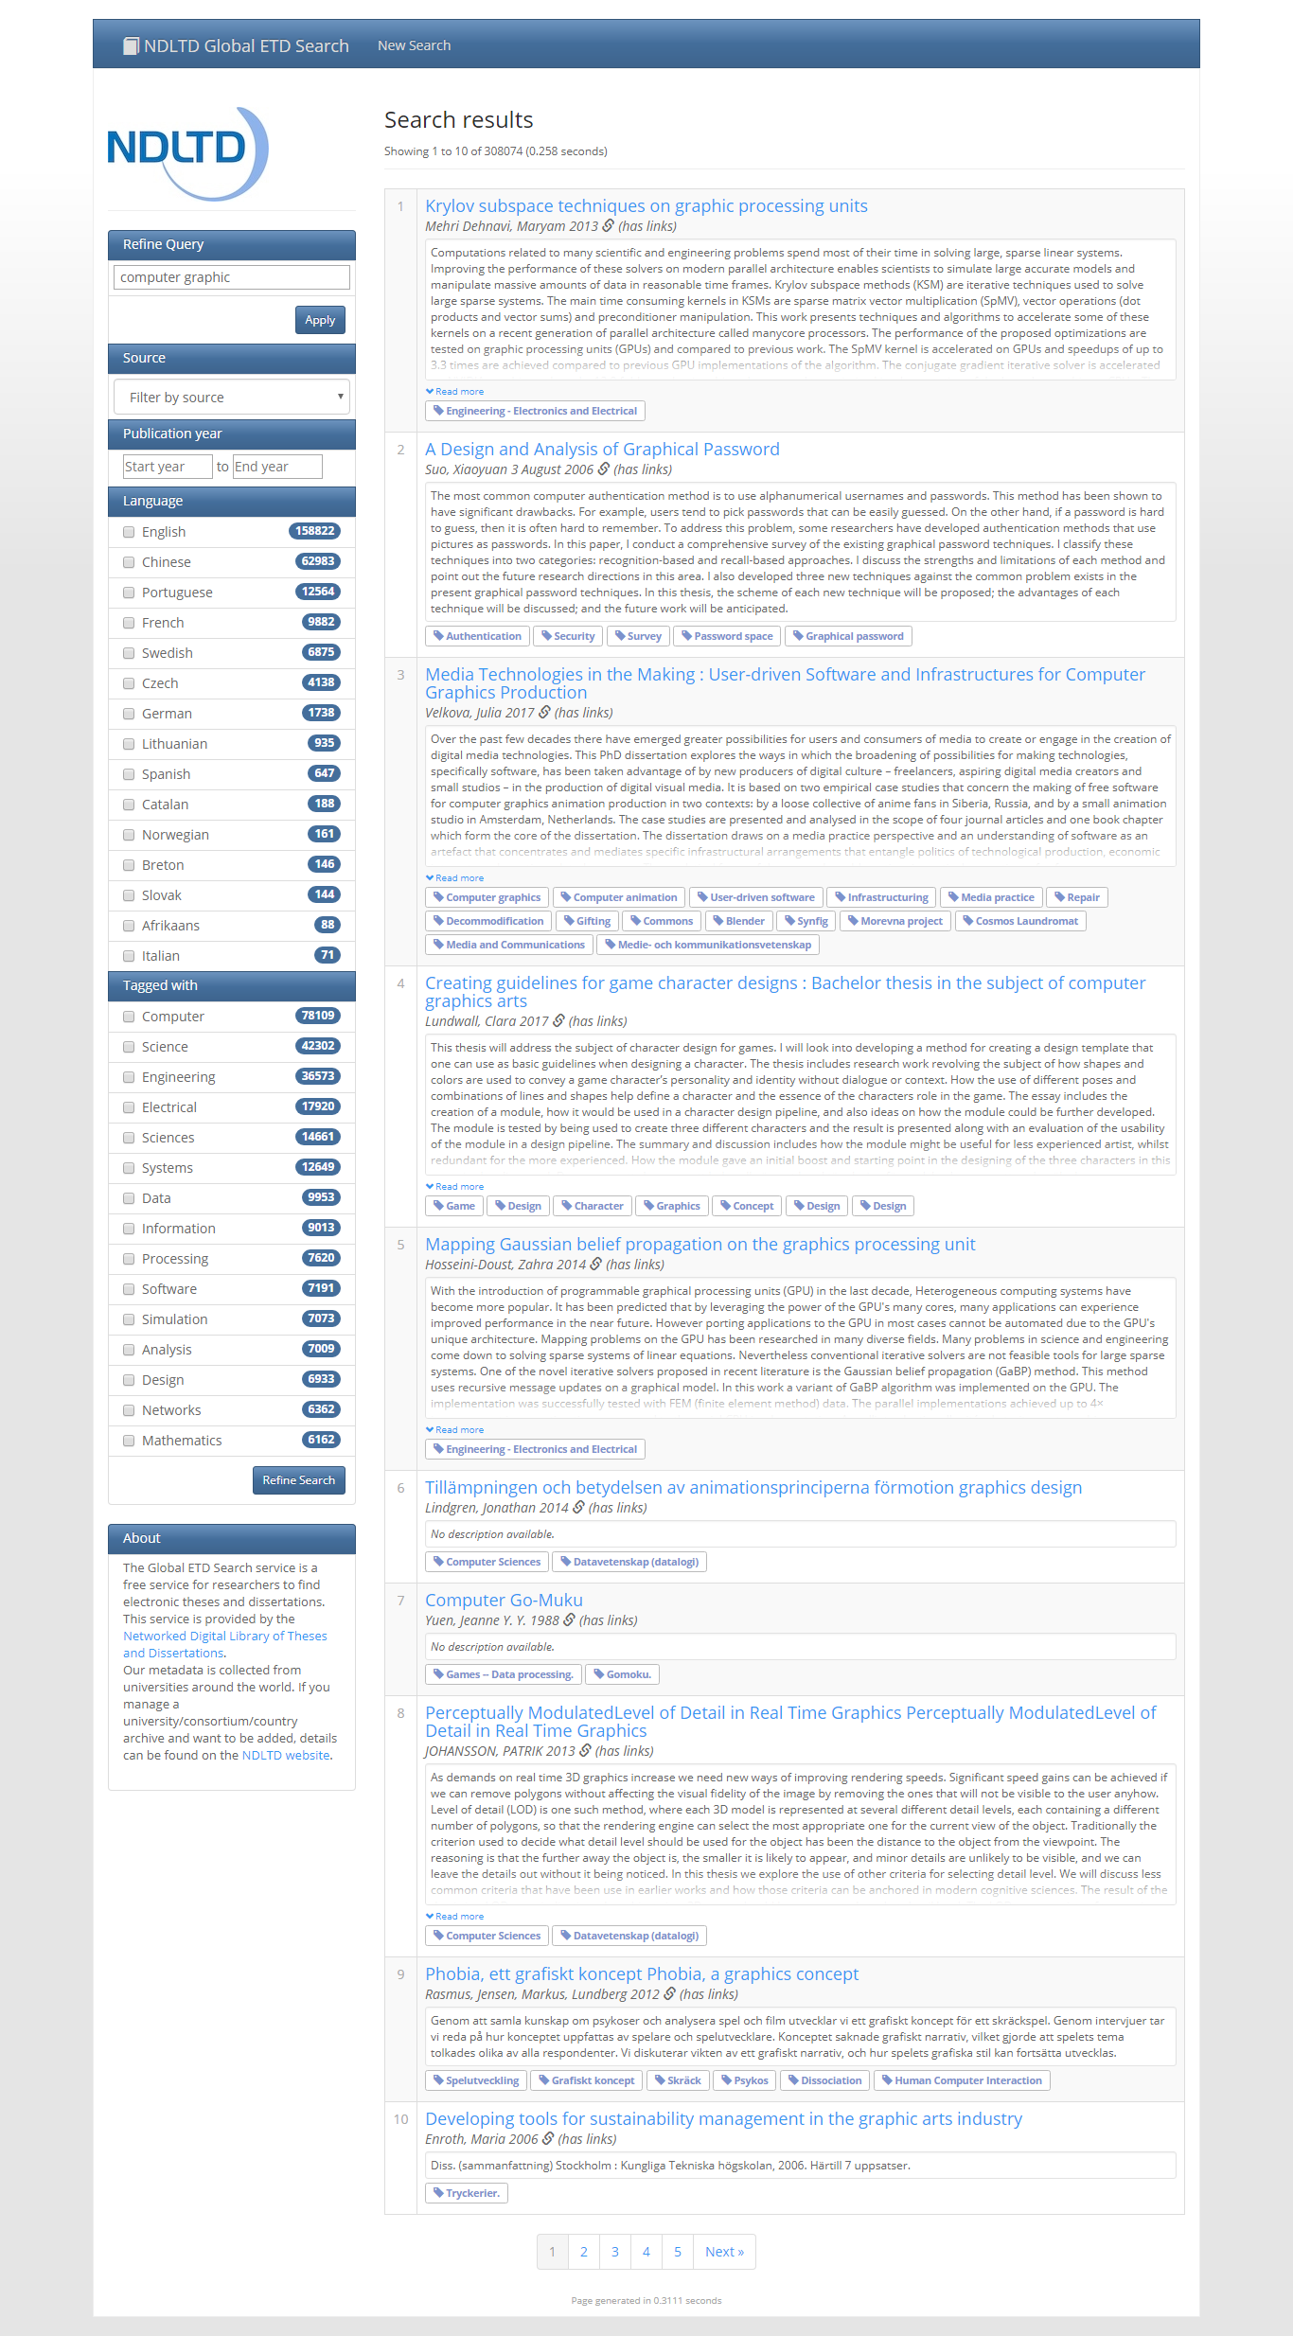

Figure (3.16) Global ETD Form

**3.2 Implementation**

When users use our system, you need to have one browser with internet access on smart phone or computer.

**3.2.1 Database Implementation**

* We used Firebase Database in our ETD project.
* Firebase Database is No-SQL Database and No-Relational Database (No tables)
* It works as a tree.
* Data are inserted in the database as a child node.

**Firebase RealTime Database**

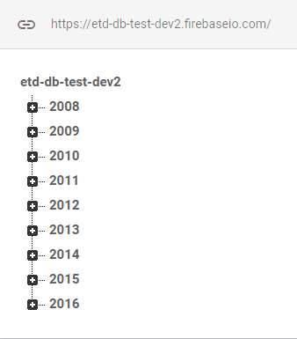

Figure (3.17) Data Of Project

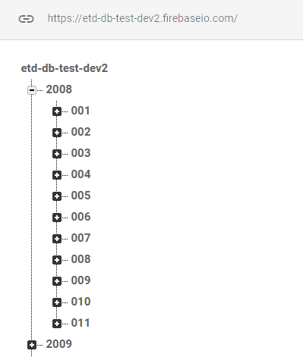

Figure (3.18) Data Of Each Year Under Project

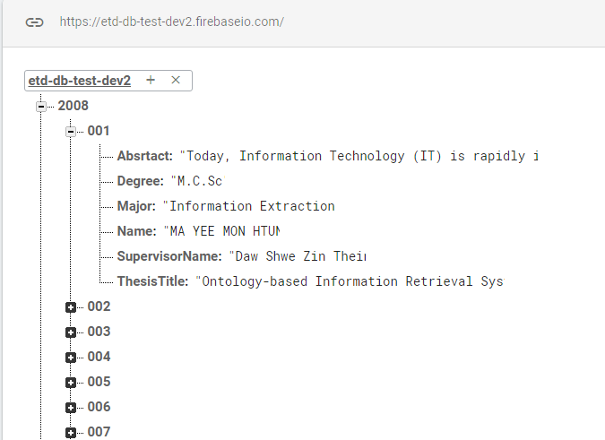

Figure (3.19) Data Of Each Id Under Year

**3.3 Testing**

This is our project milestone. We take 4 days for testing to ensure safety system.

This is how we use 4 days for testing efficiently.

|  |  |  |
| --- | --- | --- |
| **No** | **Activity** | **Day** |
| 1 | Review System Design | 1 |
| 2 | Fix Data Testing | 2 |
| 3 | Review Requirements Specification | 1 |
|  | Total Days | 4 |

Figure (3.20) Testing

**3.3.1 Integration Testing**

User enter Admin form with Email

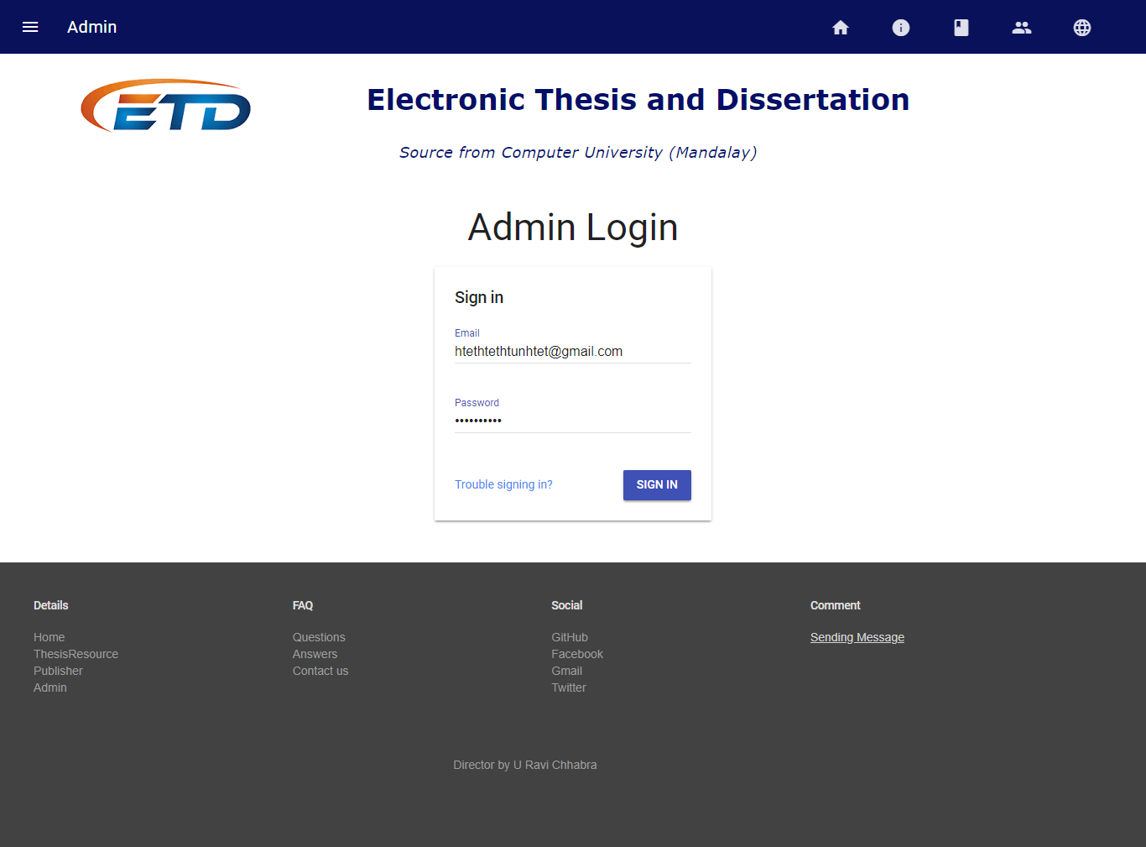

Figure (3.21) Allow Login And Check Permission

If user is an authorization Person, user can see data of each year from database.

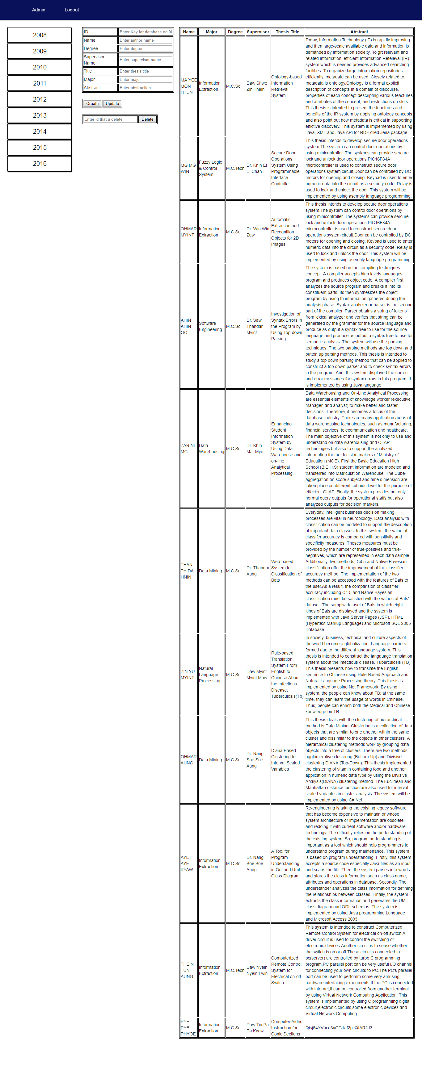

Figure (3.22) Permit Authorization Person

User enter Admin form with Email

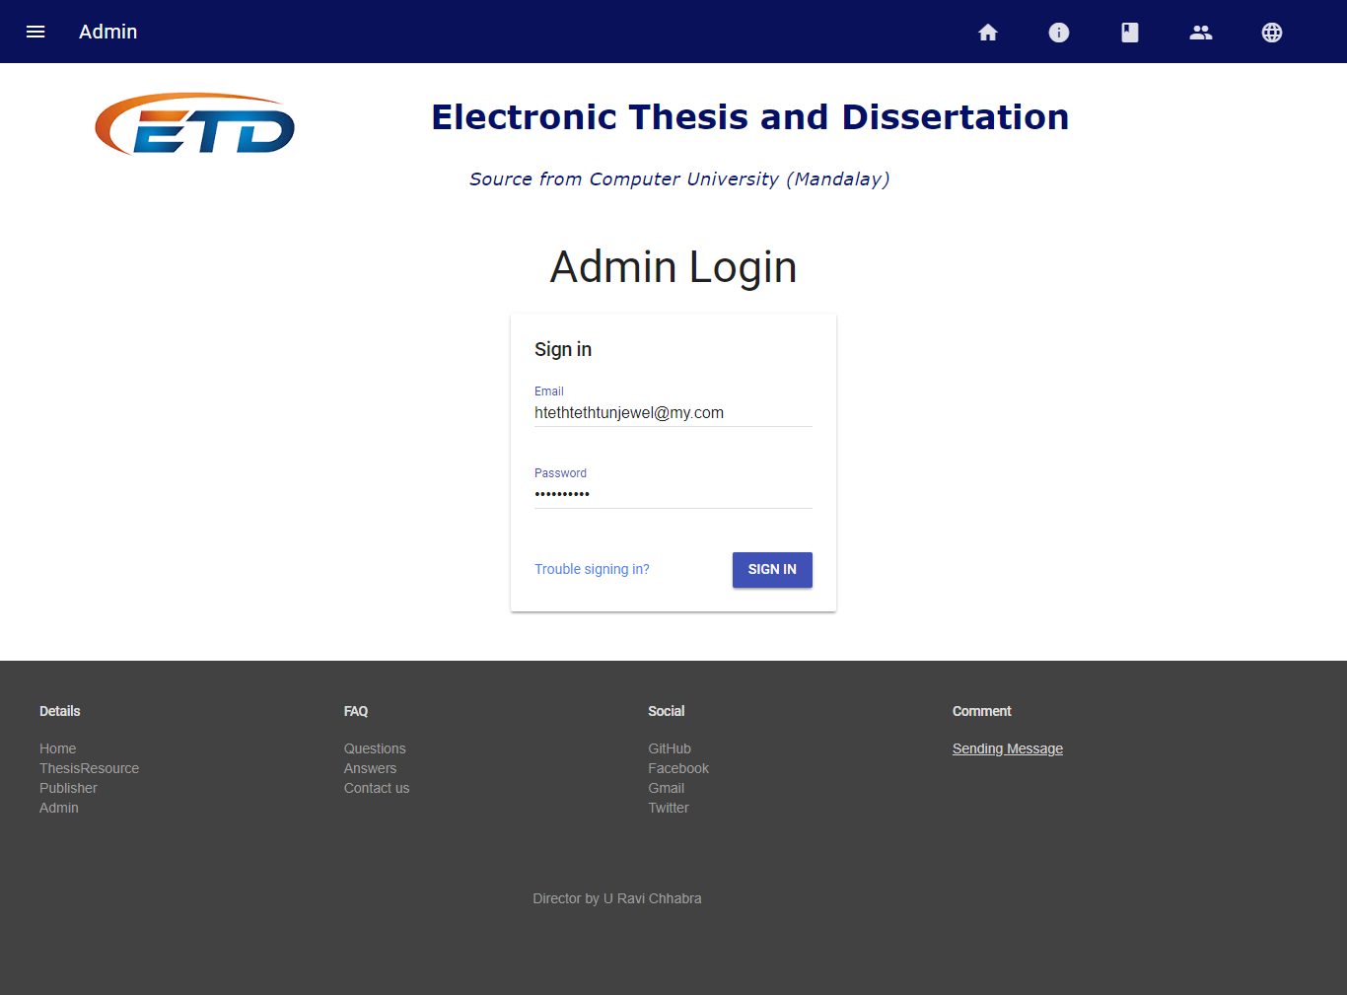

Figure (3.23) Allow Login And Check Permission

If user is not an authorization Person, user can not see data of each year from database.

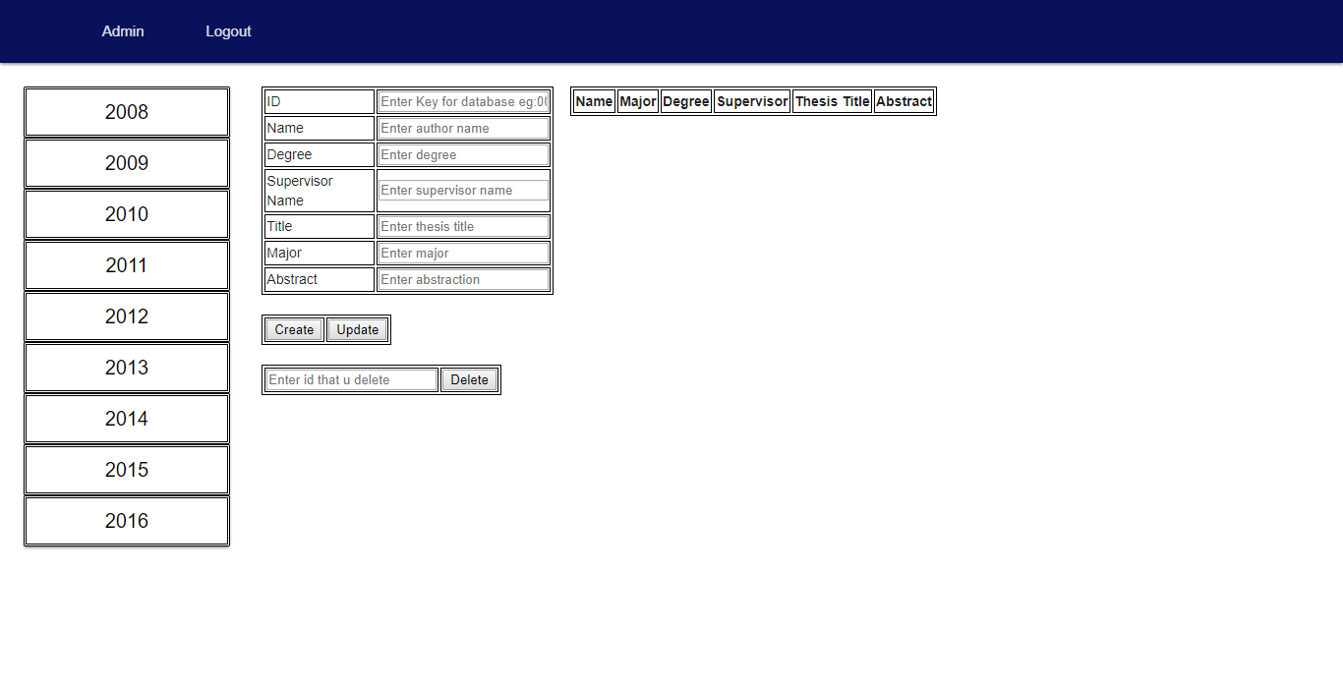Figure (3.24) Permission Deny When Not Given Authorization

**CHAPTER 4**

**EVALUATION AND CONCLUSION**

**4.1 Conclusion**

This system provides users to search easily CU (Mdy) theses from 2008-2016 with abstract. Our project has a weakness.

But we make our ETD system to find global theses and dissertations for more reference. Users can search 5,111,718 electronic theses and dissertations at Global ETD site where can find any fields that you want.

At admin panel, admin can create, retrieve, update and delete data from firebase database. And also do permissions for login users.

It doesn’t show full data of all thesis because our data are collected from CU (Mdy) library and there is no soft copy of theses.

For our project future plan, we aim to do more useful site for our university. We want to make from ETD mini project to CU (Mdy) e-Library.

**4.2** **Advantages of the Project**

The proposed system offers the following advantages:

* It provides “faster and better” services to users.
* This is helpful in assessing what’s in progress, what has written, the writing style, how it was structured, research methods, and which reference were used.
* User can satisfy because they can search not only thesis title but also by year.
* Assisting postgraduate students to write theses and dissertations.
* Provide facility for proper monitoring, reduces paper work and provide data security.

**4.3** **Disadvantages**

* The cost of computer hardware and software programs can be expensive.
* As mobile tablets use wireless network, they can disconnect with network if Wi Fi fails.

**4.4 Further Extensions**

This application has incompleteness from various view-points. Because our university doesn’t have soft copy. So, we give you abstract of thesis of our university. Various functionalities can be embedded within the project.

**Reference**

* https://www.codecademy.com/learn/learn-the-command-line
* https://www.codecademy.com/learn/learn-git
* https://github.com/
* https://github.com/mayeedwin/profile
* https://vim-adventures.com/
* https://try.github.io/levels/1/challenges/1
* https://my.wikipedia.org/
* https://about.gitlab.com/
* http://ask.tiide.org/
* https://firebase.google.com/
* http://ask.tiide.org/
* https://materializecss.com/
* https://gitlab.com/
* http://learn.freecodecamp.org/
* http://search.ndltd.org/
* https://otago.libguides.com/thesisinformation
* https://firebase.google.com/docs
* https://getmdl.io
* https://www.csvjson.com/
* https://www.onlineocr.net/
* https://www.w3schools.com/